# Tables

## 

## 1.1. Table user

1.1.1. Columns

|  |  |  |  |
| --- | --- | --- | --- |
| **Column name** | **Type** | **Properties** | **Description** |
| id | int |  |  |
| username | Varchar (50) |  |  |
| password | Varchar (64) |  |  |
| salt | Int (32) |  | Generated by password_hash. Use for validate password. |
| role | bit |  | 1 is Admin  0 is Staff |
| fullname | Varchar(50) |  |  |
| added_date | datetime |  |  |

## 1.2. Table Check_in

1.2.1. Columns

|  |  |  |  |
| --- | --- | --- | --- |
| **Column name** | **Type** | **Properties** | **Description** |
| id | int |  |  |
| user_id | int |  |  |
| time | datetime |  |  |

## 1.3. Table Check_out

1.3.1. Columns

|  |  |  |  |
| --- | --- | --- | --- |
| **Column name** | **Type** | **Properties** | **Description** |
| id | int |  |  |
| user_id | int |  |  |
| time | datetime |  |  |

# Wireframe

## Login Form

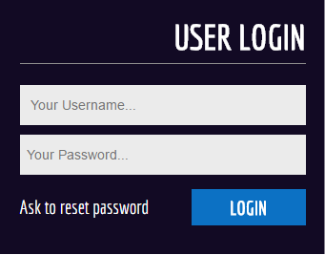

## Staff Page

## Admin Page

* + 1. 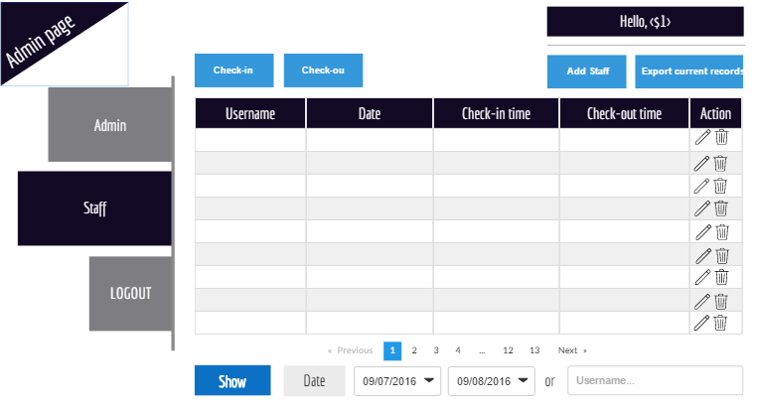Control Staff logs
       1. 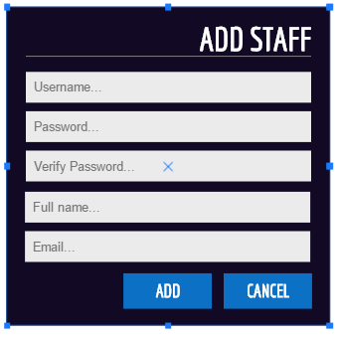Add staff form
    2. Admin promotion/revoke

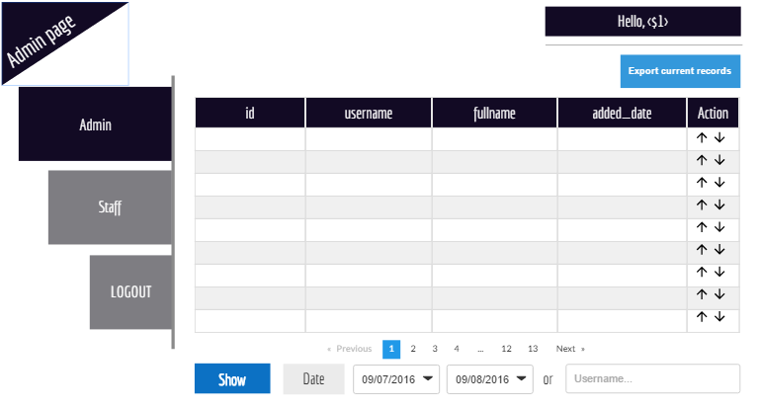

# WBS

